Chapter 1
The main goals of an operating system (OS) are as follows: MERE CSS
- Efficiency: An OS should be designed to make the best use of available hardware resources, such as CPU, memory, and storage. It should optimize the use of these resources to maximize the performance of the system.
- Reliability: An OS should be reliable and stable, meaning that it should be able to operate continuously without failure or error. It should also be able to recover quickly from errors or crashes.
- Security: An OS should be designed to provide a secure environment for computing, protecting the system from unauthorized access, malicious software, and other security threats. It should provide mechanisms for user authentication, authorization, and access control.
- Scalability: An OS should be able to scale up or down based on the needs of the system, allowing it to handle an increasing or decreasing workload as required.
- Compatibility: An OS should be compatible with a wide range of hardware and software, allowing it to support a variety of applications and devices.
- Ease of Use: An OS should be designed to be user-friendly, providing an easy-to-use interface that makes it simple for users to interact with the system and perform their tasks.
- Maintainability: An OS should be designed to be easily maintainable, allowing for updates, upgrades, and bug fixes to be installed easily and quickly without disrupting the system.
Q. Types of System Calls : FINI SPM
- File management system calls: These system calls are used for managing files and directories on a file system. Examples include:
  - open: opens a file or device
  - close: closes a file or device
  - read: reads data from a file or device
  - write: writes data to a file or device
- Process management system calls: These system calls are used for managing processes in an operating system. Examples include:
  - fork: creates a new process by duplicating the calling process
  - exec: replaces the current process image with a new process image
  - wait: waits for the completion of a child process
- Memory management system calls: These system calls are used for allocating and freeing memory dynamically in a process. Examples include:
  - malloc: allocates a block of memory
  - free: frees a block of memory
  - mmap: maps a file or device into memory
- Input/Output management system calls: These system calls are used for reading and writing data to input/output devices. Examples include:
  - read: reads data from an input device
  - write: writes data to an output device
  - ioctl: controls the behavior of an I/O device
- Networking system calls: These system calls are used for managing network communication. Examples include:
  - socket: creates a new socket for network communication
  - bind: associates a socket with a local address and port
  - listen: makes a socket ready to accept incoming connections
  - accept: accepts an incoming connection on a socket
- Inter-process communication (IPC) system calls: These system calls are used for communication between processes. Examples include:
  - pipe: creates a unidirectional communication channel between processes
  - semaphore: provides synchronization between processes
  - message queue: provides communication between processes using messages
- Signal handling system calls: These system calls are used for managing signals, which are asynchronous notifications delivered to a process. Examples include:
  - kill: sends a signal to a process or a group of processes
  - sigaction: changes the action taken by the process on receipt of a signal.

Q.
The sequence of system calls to copy one file to a new file can involve the following steps:
- Open the source file using the "open" system call. This will return a file descriptor which can be used for reading from the file.
- Open the destination file using the "open" system call. This will return a file descriptor which can be used for writing to the file.
- Read data from the source file using the "read" system call and store the data in a buffer.
- Write the data from the buffer to the destination file using the "write" system call.
- Repeat steps 3 and 4 until the end of the source file is reached.
- Close the source file and destination file using the "close" system call.
Note that this is a basic sequence and there are many variations and optimizations that can be made based on specific requirements and considerations.

Q. Structures of Operating System
- Simple Structure: Simple structures are the structures that were followed by most of the operating system that were designed at the beginning. And these simple structure operating systems did not have a very well defined structure. So, the diagram that we see here, this is the figure of a simple operating system structure that was followed by the Microsoft Disc Operating System (MS-DOS). So, here at the bottom most, we have the ROM BIOS device drivers. So, think of these as your base hardware. And then on the top of this we have the device driver, then we have the resident system programs. And then the application programs. So, we see that the device drivers have access to this basic hardware. And the resident programs have access to the device drivers as well as the basic hardware.
And then even the application program have the access to the resident program as well as the base hardware. So, we see that the base hardware can be accessed by all the things above it.
The device driver, system program, application program everything can access the base hardware.
So we see that in this structure,
the interfaces and the level of functionality are not well separated.
So, we see that application programs are able to access the basic input/output routines and write directly to the display disk driver. So, that means application programs are able to access your base hardware directly without going through these layers below it.
And we will see how it is different from this one.
So, even though this looks like a layered structure
it is not actually a layered structure.
Because all these layers have access to the base hardware.
So, what happens is that such freedom leads the MS-DOS vulnerable to errant and malicious programs, causing the entire system to crash when the user program fails. That means if you are running a program here, if an application program is being run by the user, and since it is directly accessing this base hardware, if that program fails, then that the entire system is going to crash.
Because it is having direct access.
So, we see that it is not well protected, not well structured, and also not well defined. So, this is not a very good structure.
And also we cannot blame the developers and designers for designing this.
Because as we are talking about the MS-DOS operating system,
MS-DOS actually was written on the Intel 8088.
And this Intel 8088 does not provide dual mode or any hardware protection.
So, the developers and the designers had no other option
than to just leave this base hardware accessible by all the layers above.
So, that is why it is like this.
And we can see that, this is not efficient, and not a good structure.

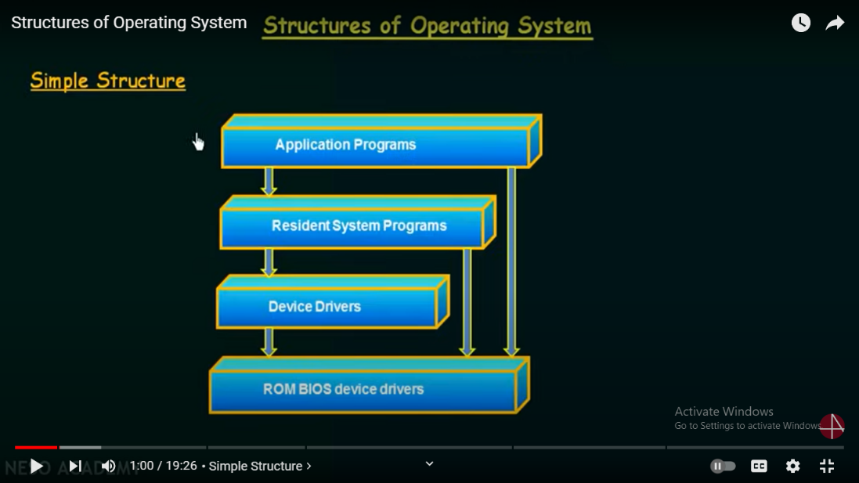
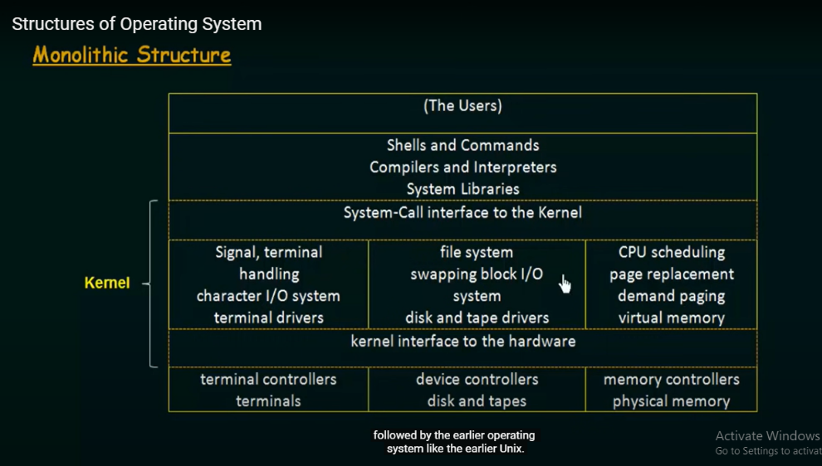
- Monolithic Architecture of Operating System: Now an another structure that we see is known as the monolithic structure. And this was followed by the earlier Unix operating systems. So, this monolithic structure is also a limited structure. Here we have the kernel and then the system programs.
So, here on the top, we have the users and below that we have shells and commands, compilers and interpreters, System libraries and so on.
And below this is the system-call interface to the kernel, that is the system call which acts as an interface to the kernel.
And the part which is everything below this system-call interface to the kernel,
and above the hardware is the kernel. This bottom most part is the hardware.
So, everything above this hardware and below the system-call interface with the kernel is known as the kernel.
And the kernel has all these functionalities like signal, terminal handling, character, input/output system, terminal drivers ,file system, swapping, block input/output system,
disk and tape drivers, CPU scheduling, page replacement demand paging, virtual memory and so on. Everything is actually packed into one level, and hence we call it a monolithic structure.
This was followed by the earlier Unix system. So, in here we see that all these functionalities
are packed into one level, which we call as the kernel. Now, the problem with this is that
there are too many functions packed into one level. And this makes its implementation and maintenance very difficult.
So, let's say that you want to add something to this, then you have to change or modify the entire thing Or let's say you want to debug a certain functionality in this kernel. Let’s say there is a problem with your CPU scheduling. So, in order to fix that issue of CPU scheduling, you will have to touch this entire kernel. So, this makes it a system that is difficult to be maintained
and implemented.
Alright!
If you want to add something into it, it also going to be difficult. This is the disadvantage of the monolithic structure. There are too many things packed into one level. So, this is also a simple and limited structure followed by the earlier operating system like the earlier Unix.

- Layered Structure:
So, now we have talked about two simple structures.The first simple structure was from Microsoft DOS.And the next monolithic structure from Unix. So, we saw that both of them were having some disadvantages. So, in order to solve that disadvantage, they came up with an another structure called the layered structure. So, in this layered structure, our operating system is divided into a number of layers.
Like for example here at the lower most layer or at the level zero, you have your hardware. Then you have layer one, layer two, up to layer n. And the top most layer is the user interface.
So, here in contrast to the monolithic system that we just saw above, where everything was packed into a single level ,here we have broken down the functionalities into different layers and separated them like these. So, the main advantage of this is that it is easy to implement and debug this one because every layer has different functionality.
And if one layer is having a problem, Let's say that the CPU scheduling layer is again having a problem.So, in order to debug that, we just have to look at that layer and debug it, instead of going and digging into the entire operating system. So, this is one of the advantages of this layered operating system.
But again we can not say that this layered approach is the best because it also has its own disadvantages. One difficulty is the designing this layered structure because you have to be very careful and specific in designing and deciding, which will be the layer on top of a certain particular layer or which will be the layer below a particular layer. because a layer can use only those layers which are below that layer. Only the services by its below layers can be used by a particular layer.
In order to make this clear let me take an example.So, let's say that we are having a layer which deals with the backing store. That means the layer which deals with disk, space, used by the virtual memory algorithm. So, there is a layer dealing with the backing store or the backing storage. Now, this layer we have to make sure that it has to be below the layer that deals with memory management.Because the memory management routine needs to use the services provided by the backing storage. So, because of that we have to make sure the backing storage layer is below the memory management layer.
So, this is just one example. So, we need to be very careful in designing this.
An another problem of this layered structure is that this may be not very efficient as compare to the other structures.Why? That is because when one layer want to use the services provided by the layers below it, the request has to go down below each layer one by one. And by the time the service is actually provided it may be late or it may not be very fast. Like let's take an example. Let's say that a user program from this layer N wants to execute an input/output operation. So, in order to execute the input/output operation, it has to get the service from this layer zero, because input/output devices are falling under this hardware. So, what it will do?
It will issue a system call. So, this layer will issue a system call in order to use the hardware.
The system call has to go through all these layers one by one and it has to reach the layer zero. So, as the system call passes through this layers, the parameters of the system calls may be modified and it will take time in reaching here and then once the system call is granted then it will be able to use the input/output devices. So, we see that as it has to pass through all these layers one by one, it is not going to be very efficient. By the time it actually gets the input/output operations as it was requested, it is going to take some time. So, that is one of the major disadvantages of this layered structure. One major advantage is that the hardware is protected from the layers above. Unlike the simple structure the user interface can not directly access the hardware. We see that it is protected because of the all these layers above it. So, that is one of the advantage.
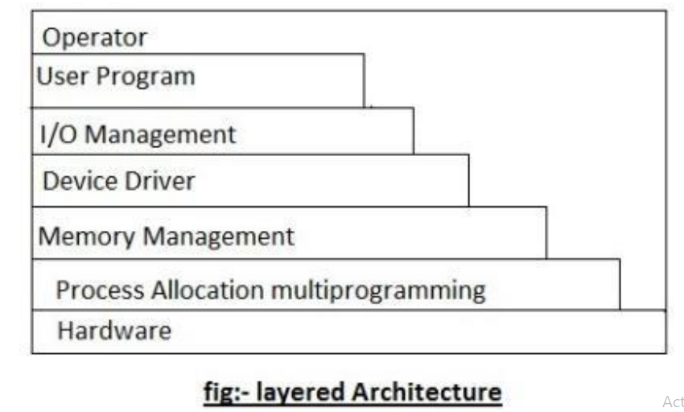

- Virtual memory architecture : From pdf
- Client Server architecture : From pdf

Chapter: 2

Q. Concurrency vs Parallelism
Concurrency is when two or more tasks can start, run, and complete in overlapping time periods. It doesn't necessarily mean they'll ever both be running at the same instant. For example, multitasking on a single-core machine. Parallelism is when tasks literally run at the same time, e.g., on a multicore processor.

Q.IPC ways to implement
Inter Process Communication (IPC) - Scaler Topics

Q.
how multiprocessor system can be effectively utilized with threads???
Multiprocessor systems can be effectively utilized with threads by allowing multiple threads to run simultaneously on different processors or cores. This can increase the overall efficiency and performance of the system by allowing multiple tasks to be executed in parallel.
The use of threads in a multiprocessor system can also improve responsiveness and provide a more interactive user experience by allowing multiple tasks to be executed concurrently without blocking or slowing down the main application.
To effectively utilize a multiprocessor system with threads, it is important to properly manage and schedule the threads to ensure that they are being executed efficiently on the available processors. This can be achieved through the use of thread libraries and scheduling algorithms that determine how and when threads are executed on the available processors.
It is also important to properly synchronize access to shared resources between threads to avoid data races and other synchronization issues that can arise in a multithreaded environment. This can be achieved through the use of synchronization constructs such as mutexes, semaphores, and other synchronization mechanisms.

Q.
advantage of implementing thread in user space
- Portability: User-space threads can run on any operating system without modification.
- Ease of use: Implementing threads in user-space can be easier than in kernel space.
- Debugging: Debugging user-space threads is easier as they are within the control of the application.
- Isolation: User-space threads are isolated from the kernel and can't crash the system.
- Resource control: User-space threads can manage their own resources and allocation of system resources can be controlled by the application.
Chatpter 5:Memory

how can we combat external fragmentation
External fragmentation can be combated by using memory allocation algorithms that allocate larger blocks of memory when possible and avoid allocating small, fragmented blocks. This can be achieved through techniques like compaction, buddy memory allocation, and slab allocation. Another approach is to use memory pooling, where memory is pre-allocated in large blocks and then divided into smaller blocks as needed, reducing the amount of fragmentation. Regular defragmentation of the memory can also help to combat external fragmentation.
Other approaches to combat external fragmentation include:
- Segregated storage allocation: This technique keeps different types of data objects in separate pools, reducing fragmentation between objects of different sizes.
- Garbage collection: This is a technique used in some programming languages where memory is automatically managed and recycled, reducing the risk of fragmentation.
- Using a contiguous memory allocator: This allocator ensures that all memory allocations are made from a single, contiguous block of memory, avoiding fragmentation.
- Paging and virtual memory management: These techniques allow the operating system to transparently move data between main memory and disk storage, freeing up space in main memory and reducing fragmentation.
- Smart allocation policies: Some allocation algorithms, like the buddy system, allocate larger blocks of memory for larger objects, reducing the amount of fragmentation.
In summary, combating external fragmentation requires a combination of smart memory management algorithms, efficient memory allocation policies, and regular memory maintenance and cleanup.

Q.Relocation and Protection:
Relocation refers to the process of adjusting the memory addresses used by a program or process when it is loaded into memory, to ensure that it can be executed correctly without causing conflicts or errors. When a program is compiled, it is assigned memory addresses that are relative to its own memory space. However, when the program is loaded into memory, these addresses may conflict with other programs or system resources that are also using memory. To avoid these conflicts, the operating system uses a technique called relocation, which involves adjusting the memory addresses of the program to ensure that it is loaded into a safe and compatible memory space.
Protection, on the other hand, refers to the mechanisms that are put in place to prevent unauthorized access or modification of memory resources. This is done by setting access permissions and boundaries for different memory regions, and by enforcing strict rules for how programs and processes can access and use memory. By protecting memory resources in this way, the operating system can ensure that each program or process is isolated from others, and that they can run safely and securely without interfering with each other.
Both relocation and protection are important concepts in modern operating systems, and are used extensively to manage memory resources and ensure the stability, security, and compatibility of software systems.

Paging:
Paging | Memory Management | Operating System | Gate Vidyalay

Q. Virtual Memory explained
Virtual memory is a computer memory management technique that allows a computer to use more memory than it physically has available. It does this by temporarily transferring pages of data from the computer's RAM (Random Access Memory) to the hard disk drive or SSD (Solid State Drive).
When a program or application is executed, it is loaded into the computer's RAM. However, if there is not enough free space in RAM to hold all the necessary data and instructions for the program, the operating system (OS) can allocate some space on the hard drive to act as a supplement to the RAM. This space is known as virtual memory.
Virtual memory works by breaking the program into smaller chunks of data called pages. These pages are then temporarily swapped between the RAM and the hard disk drive, depending on which data is currently needed by the processor. This swapping happens transparently to the user, and they do not need to know anything about it.
The operating system uses a paging system to manage virtual memory, with each page having a unique address. When the processor needs to access a page that is not currently in the RAM, the OS retrieves the necessary page from the hard disk drive and loads it into the RAM. This process is called a page fault.
Virtual memory allows computers to run large applications or multiple applications simultaneously, even if the computer does not have enough physical memory to hold all the necessary data. However, since hard drives are much slower than RAM, swapping pages between the RAM and the hard drive can result in slower performance. Therefore, it is important to have enough physical memory to avoid excessive use of virtual memory.

Virtual memory is a crucial component of modern operating systems, as it enables them to make the most efficient use of available physical memory resources. Without virtual memory, a computer's ability to run multiple applications at the same time would be severely limited.
One of the benefits of virtual memory is that it enables a computer to run larger applications than would be possible with physical memory alone. For example, a computer with 4 GB of physical memory might be able to run a large video editing application with the help of virtual memory, even if the application requires more than 4 GB of memory to operate.
Virtual memory also helps prevent crashes and system freezes by allowing the operating system to move data between physical memory and the hard drive as needed. If a program requests more memory than is available in physical memory, the operating system can allocate virtual memory to make up the difference.
However, there are some drawbacks to using virtual memory. When a computer is constantly swapping data between physical memory and the hard drive, performance can suffer. This is because the hard drive is much slower than physical memory, and so it takes longer to read and write data. Additionally, using virtual memory can cause increased wear and tear on the hard drive, which can lead to failures over time.
To optimize virtual memory performance, it is important to have enough physical memory installed in a computer, to ensure that the operating system is not constantly swapping data to and from the hard drive. It is also important to ensure that the hard drive is fast and reliable, and that there is enough free space available on the drive to accommodate virtual memory usage.

Chapter 6: I/O
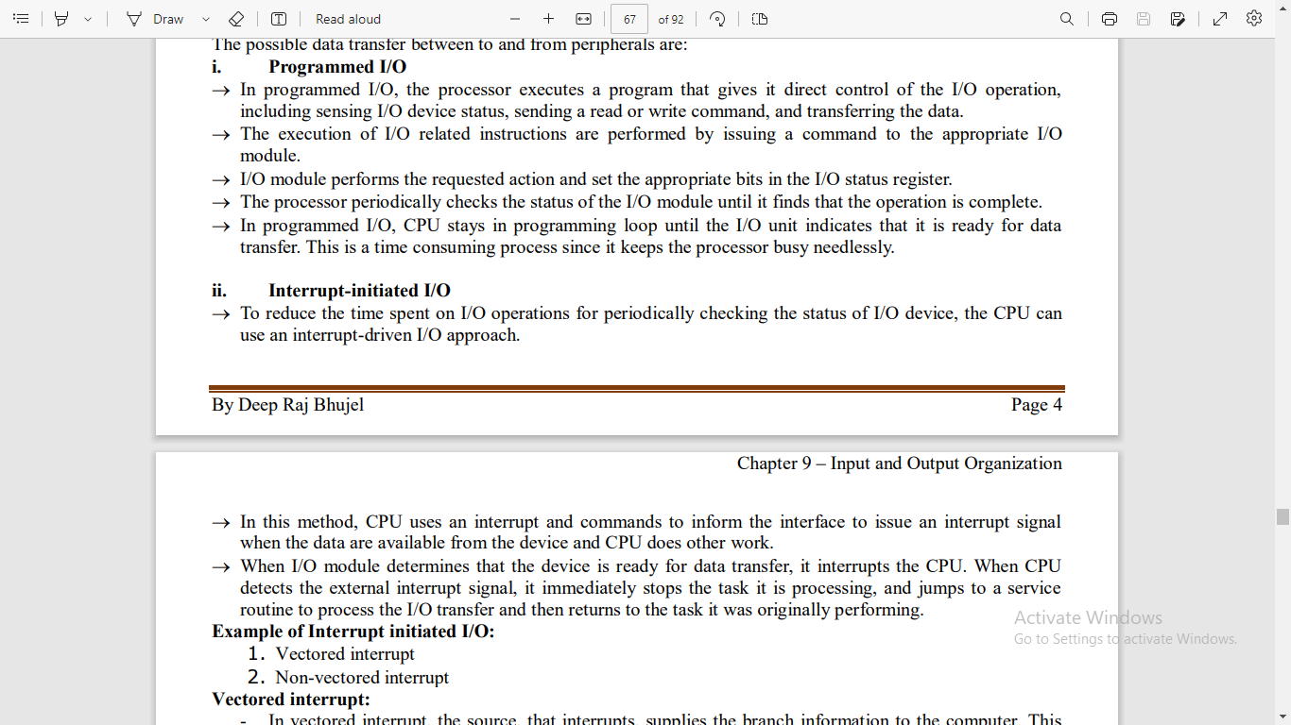

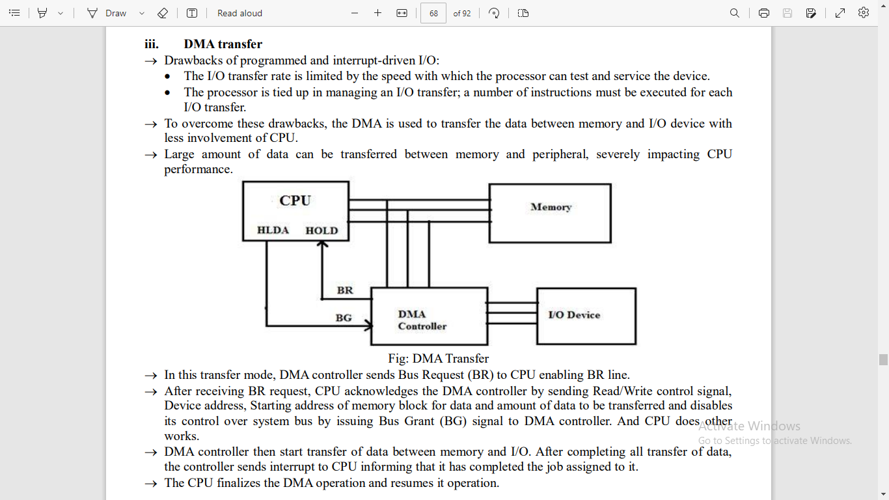
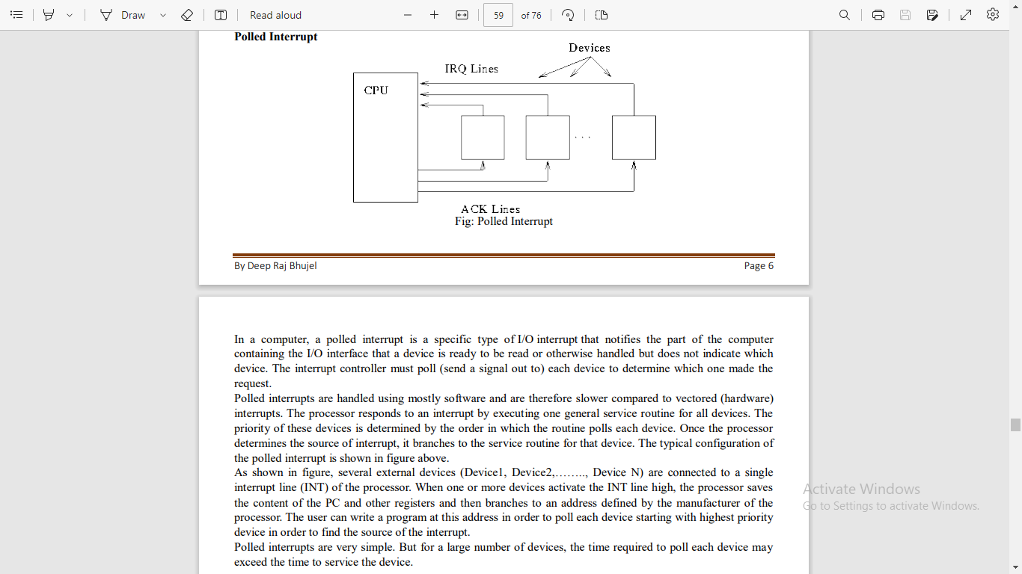
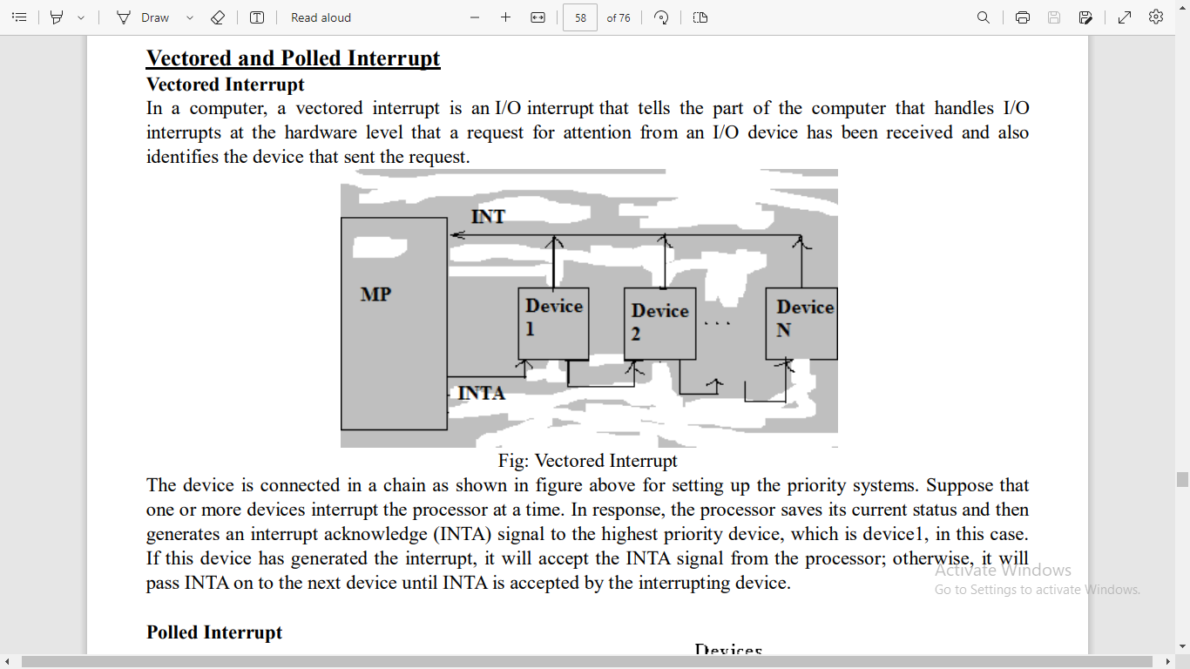

Distributed operating system characteristics /goals
Q. what does it mean by , "The end users can be concealed or hidden from the actual separation of the distributed system so that the user feels that everything is transparent to everyone"

=>
This statement means that the distributed operating system is designed in such a way that the end user (the person using the computer) is not aware of the fact that their data or application is being processed on multiple computers in a network. The user sees the system as a single, unified entity and does not need to worry about the underlying complexity of the network. The distributed operating system is responsible for coordinating the processing of data and application across multiple computers, and the end user is unaware of this coordination.
The goal is to provide a transparent view of the network, where the user does not need to be concerned about the physical separation of the system or the distribution of resources. This is achieved through techniques such as virtual memory, shared file systems, and network transparency, which allow the distributed operating system to present a unified view of the network to the end user. The end user experiences a seamless and unified computing environment, regardless of the physical separation of the system components.

Q. what does it mean by , The exchange of information and additional computation required to acheive interstic coordianation are of a form of overhead that doesnot arise in centralized system ??

=>
This statement means that in a distributed operating system, additional communication and computation is required in order to coordinate the processing of data and applications across multiple computers in the network. This additional communication and computation is referred to as "overhead."
In contrast, in a centralized system, where the operating system runs on a single computer, there is no need for this additional coordination and communication, as all processing is performed on a single machine. As a result, there is no overhead associated with inter-system coordination in a centralized system.
However, the overhead associated with inter-system coordination in a distributed system is outweighed by the benefits it provides, such as increased reliability, scalability, and better resource utilization. In other words, while there is additional overhead in a distributed system compared to a centralized system, this overhead is necessary in order to achieve the advantages of a distributed system.

Q. OSI MODEL – 7 layers explained
=>

7. Application Layer
The application layer is used by end-user software such as web browsers and email clients. It provides protocols that allow software to send and receive information and present meaningful data to users. A few examples of application layer protocols are the Hypertext Transfer Protocol (HTTP), File Transfer Protocol (FTP), Post Office Protocol (POP), Simple Mail Transfer Protocol (SMTP), and Domain Name System (DNS).
6. Presentation Layer
The presentation layer prepares data for the application layer. It defines how two devices should encode, encrypt, and compress data so it is received correctly on the other end. The presentation layer takes any data transmitted by the application layer and prepares it for transmission over the session layer.
5. Session Layer
The session layer creates communication channels, called sessions, between devices. It is responsible for opening sessions, ensuring they remain open and functional while data is being transferred, and closing them when communication ends. The session layer can also set checkpoints during a data transfer—if the session is interrupted, devices can resume data transfer from the last checkpoint.
4. Transport Layer
The transport layer takes data transferred in the session layer and breaks it into “segments” on the transmitting end. It is responsible for reassembling the segments on the receiving end, turning it back into data that can be used by the session layer. The transport layer carries out flow control, sending data at a rate that matches the connection speed of the receiving device, and error control, checking if data was received incorrectly and if not, requesting it again.
- Segmentation : sequence number and port number
- Flow control : controls the amount of data transmitted , speed control
- Error control
3. Network Layer
The network layer has two main functions. One is breaking up segments into network packets, and reassembling the packets on the receiving end. The other is routing packets by discovering the best path across a physical network. The network layer uses network addresses (typically Internet Protocol addresses) to route packets to a destination node.

2. Data Link Layer
The data link layer establishes and terminates a connection between two physically-connected nodes on a network. It breaks up packets into frames and sends them from source to destination. This layer is composed of two parts—Logical Link Control (LLC), which identifies network protocols, performs error checking and synchronizes frames, and Media Access Control (MAC) which uses MAC addresses to connect devices and define permissions to transmit and receive data.
1. Physical Layer
The physical layer is responsible for the physical cable or wireless connection between network nodes. It defines the connector, the electrical cable or wireless technology connecting the devices, and is responsible for transmission of the raw data, which is simply a series of 0s and 1s, while taking care of bit rate control.

Advantages of OSI Model
The OSI model helps users and operators of computer networks:
- Determine the required hardware and software to build their network.
- Understand and communicate the process followed by components communicating across a network.
- Perform troubleshooting, by identifying which network layer is causing an issue and focusing efforts on that layer.
The OSI model helps network device manufacturers and networking software vendors:
- Create devices and software that can communicate with products from any other vendor, allowing open interoperability
- Define which parts of the network their products should work with.
- Communicate to users at which network layers their product operates – for example, only at the application layer, or across the stack.

Difference Between OSI and TCP/IP Model
OSI | TCP/IP
Developed by ISO. | Developed by ARPANET.
It is only a reference model and no actual implementation is done on this model. | This model is used for the development of the internet.
Stands for: Open System Interconnection. | Stands for: Transmission Control Protocol/Internet Protocol.
The transport layer confirms the delivery of the packets. | The transport layer does not confirm the delivery of the packets.
A vertical approach followed. | A horizontal approach followed.
Presentation and Session layers are different. | Both are the same and are included under the application layer.
It can be used to build models like TCP/IP. | It cannot be used for model building.
The network layer can provide connectionless service as well along with connection service. | The network layer can only provide connectionless service.
There exist 7 layers. | There exist 5 layers.
Used very less compared to TCP/IP. | Highly used.

Q. What are the different network architectures in distributed system?
There are several network architectures that can be used in a distributed system, depending on the specific requirements of the system and the nature of the applications being run. Some of the common network architectures used in distributed systems include:

Client-Server Architecture: This architecture is the most common network architecture used in distributed systems. In this architecture, a set of client computers communicate with a set of server computers over a network. The server provides services to the clients, such as file sharing, printing, and database management.

Peer-to-Peer Architecture: In a peer-to-peer architecture, each computer in the network acts as both a client and a server. There is no central server, and each computer can communicate directly with any other computer in the network. This architecture is commonly used for file sharing and other collaborative applications.

Clustered Architecture: In a clustered architecture, a group of computers are connected to form a cluster, and they work together to provide a single system image. Each computer in the cluster runs the same operating system, and they all share a common set of resources, such as storage and memory.

Grid Architecture: A grid architecture is a distributed system in which resources are shared across multiple administrative domains (MAD). It is used for applications that require large amounts of computing power and storage, such as scientific simulations and data analysis.

Cloud Architecture: In a cloud architecture, resources are delivered as a service over a network. Cloud architectures can be public or private, and they can provide a range of services, including computing power, storage, and software applications.

These are some of the common network architectures used in distributed systems. The choice of architecture will depend on the specific requirements of the system and the nature of the applications being run.

Hybrid Architecture: This architecture is a combination of two or more network architectures, such as client-server and peer-to-peer. A hybrid architecture is often used when different applications or services within a distributed system have different requirements and constraints.

Message-Oriented Middleware Architecture: In this architecture, applications communicate through a messaging system that provides a reliable and scalable way to transmit messages between distributed components. This architecture is commonly used in large-scale enterprise applications.

Publish-Subscribe Architecture: This architecture is used for event-driven applications in which components can subscribe to receive notifications about specific events. When an event occurs, the component that generated the event publishes it to the system, and the components that subscribed to the event receive the notification.

Service-Oriented Architecture: Service-oriented architecture (SOA) is an architectural style that uses a collection of services to support the requirements of business processes. In SOA, each service is a self-contained unit of functionality that can be invoked over a network using standard protocols.

Microservices Architecture: This architecture is similar to SOA, but it focuses on creating small, independently deployable services that can be developed and maintained by small, cross-functional teams. Microservices architecture is often used in cloud-based applications and other distributed systems.

These are just a few examples of the different network architectures used in distributed systems. The choice of architecture will depend on factors such as the requirements of the system, the nature of the applications being run, and the resources available to the system.

Q. Difference between end users and environment users .

End users are individuals who directly interact with and utilize a system, product, or service for its intended purpose. They are the final consumers of the product.
On the other hand, environment users refer to individuals or systems that support or facilitate the use of a product or service by end users. These users are typically involved in setting up, maintaining, or enhancing the technology infrastructure that enables the product or service to function.
For example, in a company, end users may be employees who use software applications to perform their job tasks, while environment users may be IT professionals who are responsible for deploying, managing, and updating the software and hardware infrastructure used by the employees.

1) virtual memory: we are trying to get the maximum amt. of processes, with very big sizes.
2) when a process is running, the CPU will say that he needs a particular page of the process.
3) the request goes to the MMu. the MMU will check in the paging table. if a page is in the RAM, the availablility bit is set to 1. else it is set to 0.
4) if the Avalability bit is set to 0 then a trap is generated.
5) the control of the CPU goes from the USer proces to the OS.
6) the OS first authenticates the user process who is trying to access pages.
7) after that the required page is loaded from the HDD into the RAM.
8) the Page table in the MMU is updated, which says that the Page lies in x Frame of the RAM.
9) the control of the CPU return back to the User process.

Chapter 9: Case Studies

Q. Explain about System configuration, filing and disk management, graphical capabilities and memory management of DOS operating system in simple language
System Configuration: System configuration refers to the settings and parameters that are used to set up and configure a computer's hardware and software. In DOS, you can configure your system using various commands and tools such as CONFIG.SYS and AUTOEXEC.BAT files. These files allow you to specify system settings like the amount of memory to allocate, the location of device drivers and system files, and other options that control how your computer operates.
Filing and Disk Management: Filing and disk management refer to how DOS handles files and stores them on your computer's hard drive. In DOS, you can use commands like DIR, COPY, and DEL to view, copy, and delete files. You can also use tools like FORMAT to prepare a disk for use and CHKDSK to check for errors on a disk. DOS uses a file system called FAT (File Allocation Table) to keep track of files on a disk.
Graphical Capabilities: DOS is primarily a command-line operating system, which means that it doesn't have the same graphical user interface (GUI) that you might be used to in modern operating systems like Windows or MacOS. However, DOS does have some basic graphical capabilities, such as the ability to display graphics and text in different colors and fonts using commands like MODE and COLOR.
Memory Management: Memory management refers to how DOS manages the computer's memory, which is the temporary storage space that programs use to run. In DOS, memory management is important because DOS has limited memory resources. You can use commands like MEM and EMM386 to manage your computer's memory, allocate memory to different programs, and optimize memory usage. DOS also uses a system of memory partitions to manage memory between different programs running at the same time.

Q. Explain about system architecture, memory , process management and communication in AMOEBA operating system.
AMOEBA is a distributed operating system that was developed in the 1980s by Andrew S. Tanenbaum and his colleagues at Vrije Universiteit in Amsterdam. It was designed to run on a network of computers, and its architecture reflects this distributed nature.
System Architecture: AMOEBA's system architecture is based on the client-server model, which means that the system is divided into two types of processes: servers and clients. Servers provide services to clients, such as file storage, printing, and communication, while clients request these services from servers. AMOEBA uses a microkernel architecture, which means that the kernel is kept small and simple, and most of the operating system's functionality is implemented as user-level processes.
Memory Management: AMOEBA's memory management is designed to be distributed across multiple computers. Each computer in the network has its own local memory, which can be accessed by processes running on that computer. In addition, AMOEBA provides a distributed shared memory system, which allows processes to share memory across different computers in the network.
Process Management: AMOEBA's process management is also designed to be distributed across multiple computers. Processes can be created and run on any computer in the network, and can communicate with each other using remote procedure calls (RPCs). AMOEBA's process management system also includes mechanisms for process migration, which allows processes to be moved between computers in the network without disrupting their operation.
Communication: AMOEBA's communication system is based on message passing, which means that processes communicate with each other by sending and receiving messages. AMOEBA provides a reliable message delivery system, which ensures that messages are delivered in the order in which they were sent and that no messages are lost or duplicated. In addition, AMOEBA's communication system includes mechanisms for remote procedure calls (RPCs), which allow processes to call functions on other computers in the network as if they were local functions.
Overall, AMOEBA's distributed architecture and sophisticated memory, process, and communication management systems make it a powerful operating system for running on networks of computers.

